

January 17, 2020

Coaches/ Executive/Volunteers

- Fill out the letter from Mount Forest Minor Hockey, in regard to the record check.

- |Fill out a copy of the Vulnerable Sector Check, 2 pages.

- If you have a criminal record to declare, as required fill out the Declaration of Criminal Record. If you DO NOT have a Criminal Record you do not need to fill out this form.

- Photo copy 2 pieces of ID. 1 must be a photo ID.
Acceptable photo ID, drivers license, passport, military ID, etc. Acceptable non-photo ID, birth certificate,
DO NOT try and use Health Card or SIN Card.

Drop the documents #1-4 off at the OPP Station in Teviotdale.

Upon completion of the check, you will be contacted by the OPP Station to pick up your check. Then provide the information contained to myself.

If you require any more information, please contact me at 226-991-0091

Amanda Cailes-Rice
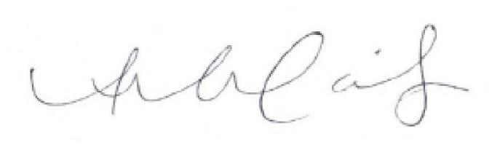

President, Mount Forest Minor Hockey



January 17, 2020

To Whom It May Concern,

This letter is to confirm that is a volunteer for Mount
Forest Minor Hockey (MFMH) for the 2020-2021 season. In this role, this individual will be interacting with children aged 4-18.

Because our volunteer will be in contact with vulnerable persons on an individual, group and team basis, we require a Police Records Check including Vulnerable Sector Check be completed. Please assist ________________ through this process.
If you require any more information, please contact me at 226-991-0091.

Amanda Cailes-Rice
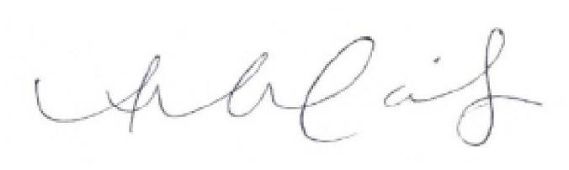

President, Mount Forest Minor Hockey


