September 1, 2022

To Whom It May Concern,

This letter is to confirm that is a volunteer for Mount
Forest Minor Hockey (MFMH) for the 2022- 2023 season. In this role, this individual will be interacting with children aged 4-18.

Because our volunteer will be in contact with vulnerable persons on an individual, group and team basis, we require a Police Records Check including Vulnerable Sector Check be completed. Please assist ________________ through this process.

Should you require any more information, please contact me at 226-991-0091.

Amanda Cailes
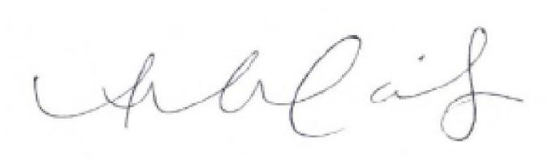

Town Contact, Mount Forest Minor Hockey

