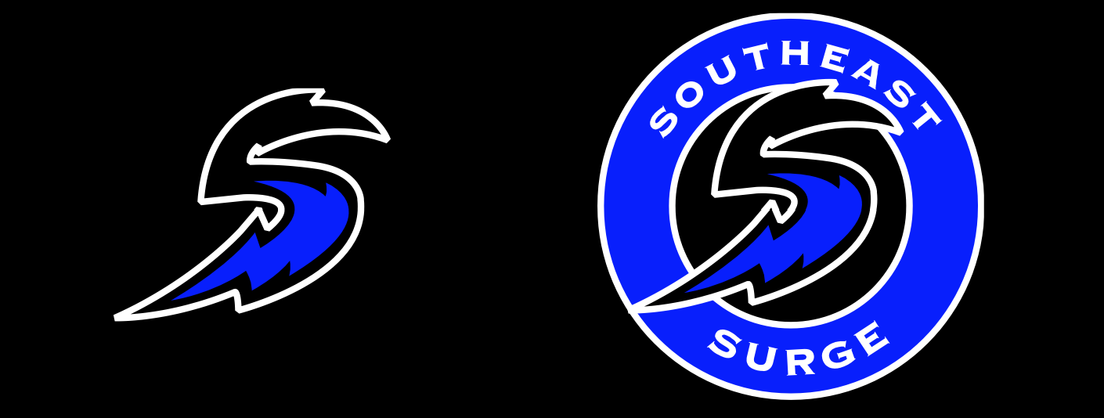

2025-2026 Coach Announcement
The Coach Selection Committee would like to congratulate the following coaches who have accepted positions for the 2025-26 season A Teams:

AGE | Coach
U10 (2016) | Zac Graham
U11 (2015) | Steve Zmudczynski
U12 (2014) | Mark Stanley
U13 (2013) | TBA at a Later Date
U14 (2012) | TBA at a Later Date
U15 (2011) | Jason Cummings
U16 (2010) | TBA at a Later Date
U18 (2009/2008) | Shawn Livingston

For those individuals still interested in helping coach, please find the below link to the application for submission. With May tryouts quickly approaching we hope you can Surge into our application process to Coach and Guide the next generation of local players in the open A and B Representative age groups. Please fill out your application today, we look forward to hearing from you.
https://southeastsurgehockey.com/Public/Documents/Southeast_Coach_Application.doc
We look forward to a great upcoming inaugural season. Please keep on the look out for future updates including tryout registration

